5G智慧灯杆
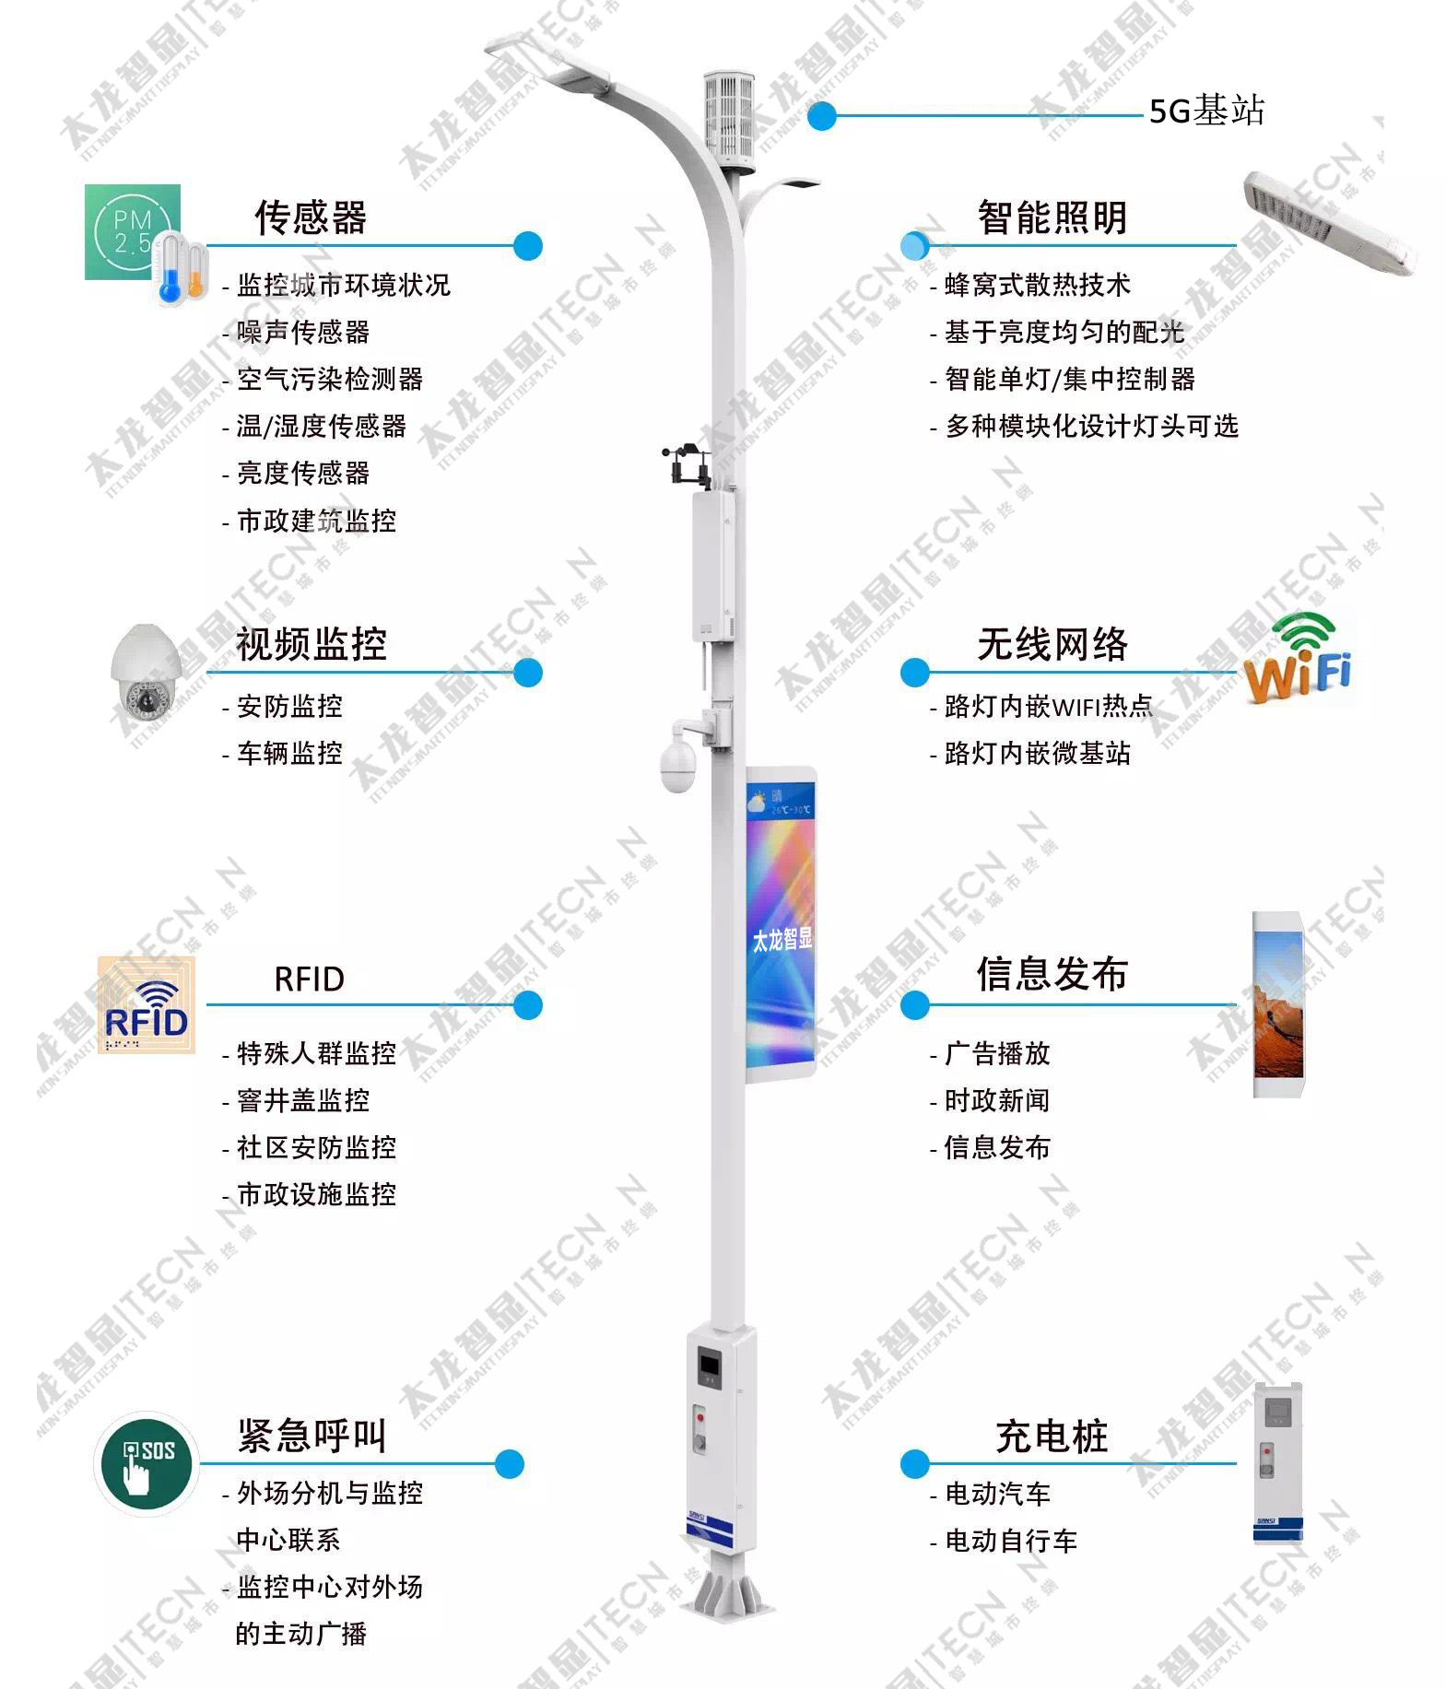
更所资料请来电咨询：郝总15919811116

